Walmart Corporate Analysis
Strategies & Decision Making
Bodey Yaeger

Table of Contents:

Executive Summary 3
Company Background 3 - 4
Company Research 4 – 19
Situation Analysis 20
Alternatives 20 – 22
Recommendations 22 – 23
Implementation 24 – 25
Contingency 27 – 28
Bibliography 26 – 27

Executive Summary
In this analysis, I will analyze Walmart’s background and conduct an in-depth research analysis of the company which highlights the organization’s strengths and weaknesses, as well as a profile of their customers, and both an internal and external analysis of their industry. I will continue to explain the current competitive situation they face in regard to the ever-changing and bustling e-commerce industry. Lastly, I will highlight three alternative recommendations which I believe Walmart could take to address this issue and explain why I believe investing in a stronger e-commerce infrastructure and technology enhancements will help the company prosper well into the future.
Background of the Company
Walmart was founded in 1962 by a man named Sam Walton; the first store was opened in Rogers, Arkansas. This was coined as the retail revolution due to Walton’s ingenious business structure, which was to provide the lowest prices anytime, anywhere. The company saw great growth throughout the sixties which led them to officially incorporate as Wal-Mart Stores, Inc. in 1969. Following this incorporation, they continued their growth into the 70s and 80s by becoming publicly traded on the New York Stock Exchange, which led to rapid expansion across the United States making them a large force in the retail industry. In fact, in 1980, Walmart became the fastest company to reach $1 billion in annual sales. The 80s were also characterized by Walmart expansion into supercenters which would combine the convenience of a supermarket along with general merchandise, along with the introduction of a sister company, Sam’s Club. These new stores provided great convenience to customers and helped bolster their retail position and increase their market share even more. By the 90s, Walmart had established themselves as the king of the retail game in the United States. That being the case, they decided to branch out and open their first international store with a Sam’s Club in Mexico City, Mexico. Sam Walton sadly passed away in 1992 at the age of 74, but before he passed, he articulated the company’s mission. Walton’s mission for Walmart was “saving people money so they can live better”. This mission has lived on to this day as it is the go-to slogan you hear when you see or hear any Walmart advertisement or commercial. The 2000’s and onward, Walmart continued its growth and expansion globally, as well as their expansion into the internet and e-commerce. Today, the retail giant is still the top dog in the ever so bustling retail industry, and it’s continuing to innovate and find new ways to save people money so they can live better.
Company Research
As previously stated, Walmart’s long-standing mission is to save people money so that they can live better. This is where Walmart is able to provide its unique value to its customers. How is this value created exactly? That question is best answered through a critical analysis of Walmart’s value chain. To conduct this analysis, we must first analyze Walmart’s primary activities which include their inbound logistics, operations, outbound logistics, marketing & sales, and services. Walmart’s inbound logistics have been long raved about as they have been able to create a slur of strategic partnerships with vendors and suppliers both locally and globally. This success has been accredited to their “Supplier Alliance Program” which helps enforce quality assurances and price controls. Moreover, Walmart has a streamlined inventory management system in which they have implemented the strategies of cross docking and direct store delivery. Cross docking is a process where they accelerate the unloading/loading process by taking packages directly from an inbound truck and putting it directly on an outbound truck to help reduce warehousing expenses. Direct store delivery is a process where they have suppliers deliver their products to their stores for them, which often means those vendors are then responsible for the management of their products inventory within their stores. This in turn helps Walmart effectively manage their surplus of these vendor goods and they can facilitate deliveries to come right on time in order to replenish those goods.
The next aspect of Walmart’s primary activities is their operations. Walmart ensures that their stores have a massive array of products for consumers to choose from with over 60 different departments. In fact, “every Walmart store holds an average of 120,000 product units, evidencing the enormity of their operation.” (Boardmix) Aside from their wide array of offerings, they have also designed their physical stores to be easy for customers to navigate through while they attempt to keep eye catching products featured in the center aisles in hopes that it gets customers to wander off into aisles in search for similar or related products. They also operate heavily in e-commerce as the internet is always evolving and their biggest competitor, Amazon, primarily generates revenues through e-commerce sales. As previously mentioned, Walmart has a stellar inventory management system, and this aids their operations s they experience low numbers of shortages and overstocks.
The third part of Walmart’s primary activities is their outbound logistics. Walmart, yet again, has set themselves apart from their competitors in terms of shipping and handling. In 2020, “Walmart operated a fleet of approximately 6,100 trucks and 61,000 trailers, which facilitated the shipment of over 1.5 billion cases to its stores.” (Boardmix) This shows the magnitude of their outbound operations and how important this activity is to them. Walmart found it best to operate using a hub and spoke system for their distribution processes, where their distribution centers operated as the hub, and the stores surrounding it within a given radius are the spokes. The location of these “spokes” should be close enough for truck drivers to arrive in one day effectively optimizing the size of the shipments being sent as well as minimizing shipping costs. On top of all of that, Walmart also utilizes a transportation management system which aids in planning and tracking shipments in order to reduce shipping errors and improve delivery times. Recognizing just how large their outbound logistics are, Walmart also decided to implement a “Zero Waste Initiative” where they use renewable fuels in their trucks to transport goods and to reduce emissions.
The fourth portion of primary activities discusses Walmart’s marketing and sales. As previously mentioned, Walmart strives to be the lowest cost retailer in the industry to save people money so that they can live better. They have spent billions of dollars reiterating this mission into their marketing and sales efforts. Walmart analyzed and acknowledged just how important advertising is within their industry, so “In February 2019, Walmart brought all of its ad operations inhouse under Walmart Media Group, which has since rebranded as Walmart Connect.” (Marketline) By making this move, Walmart has been better able to access information on their customer base and further extend their offerings and operations through their omnichannel presence. In recent years, Walmart has primarily focused on their digital sales and marketing efforts since a vast majority of individuals spend hours upon end on the internet and smartphones. This has included the use of numerous promotional campaigns, including but not limited to, clearance sales, special event promos, as well as seasonal sales. Furthermore, the newest addition to Walmart’s marketing and sales initiatives is Walmart+ subscriptions. With a Walmart+ subscription, customers get access to everyday low prices, 90+ hours & $1300+ saved a year, gas price savings at over 14 thousand locations, faster in-store shopping with Scan & Go, free same-day grocery delivery, and a free Paramount+ subscription. All of these efforts combined have set Walmart up for continued success in the future and has shown that they’re dedicated to making their customers’ lives easier.
The fifth and final part of Walmart’s primary activities includes services. Walmart has sought to make customers’ shopping experiences in their stores even better by saving them time. They have done a stellar job of improving their services offered primarily through the use of technology. One of the most recent services they’ve added to their stores is an online grocery pickup program which allows customers to do their shopping online and drive to the store to have their items loaded into their car for them. Another way they’ve used technology to serve their customers is with the use of AI floor cleaners to ensure the sales floor is kept up to standard. Walmart cares so much about the service they provide their customers that in 2019, they “allocated $5.6 billion capital expenditure to develop e-commerce, technology, supply chain, store remodel and other initiatives in order to improve its service to customers.” (Marketline) Overall, Walmart has done a fabulous job both managing and improving their services for their customer base.
Now that all of the primary activities have been discussed, it is time to address the secondary activities which include the firm’s infrastructure, human resources, technology, and procurement processes. First, let’s discuss Walmart’s infrastructure. Walmart operates globally which gives them a great deal of geographic coverage when it comes to getting in touch with their consumers. This has been largely accredited to huge investments in technology which helped them know their consumer base resulting in even more prosperity. Walmart’s infrastructure is comprised of technologically advanced inventory management and logistics systems, as previously mentioned, which in turn help them offer the wide array of diverse products that we’ve come to expect in store and online.
The next aspect of Walmart’s secondary activities to be discussed is human resources. One of Walmart’s greatest resources is the number of employees they have. In fact, Walmart has over 2.2 million employees worldwide, which shows the sheer magnitude of their workforce. Walmart has been known for using technology in their human resource management systems to help ensure that their stores are adequately staffed, varying in their busiest and slowest times and days of the week. Their human resource team also assigns employees to training and development programs to ensure that they are taught and educated in the necessary skills and knowledge to carry out their job functions. Furthermore, Walmart also trains their upper-level workforce at locations known as Walmart Academies. Store managers and other executives participate in these in-house training programs to harness the skills necessary to perform their job functions adequately. Lastly, Walmart’s human resources also seeks to reduce turnover by offering their employees competitive wages, health programs, and different engagement programs.
Third, we must discuss Walmart’s technology development. Many of their technological advancements have already been highlighted in other sections; however, here is another run down. Technology is pivotal to Walmart’s success and how they provide value to their customers. This encompasses but is not limited to their supply chain management, inventory management, services, marketing, and sales, etc. No matter what activities Walmart takes place in nowadays, they always seek to maximize their potential by utilizing technology to enhance their customer’s experience.
Lastly, we must analyze Walmart’s procurement processes. Walmart has been able to maintain such a lucrative market position for so long, primarily through their positive relationships with suppliers. Walmart does an excellent job ensuring they have an extensive supply chain through communicating with suppliers and negotiating fair and appealing deals with them. They have also been able to use their technological advancements in this process by helping them predict forecasted demand and inventories so that they can convey this information to their suppliers, further strengthening their relationships with them. All of the following factors combined are what gives Walmart such a great competitive advantage in their industry. The sum of these factors enables Walmart to create a unique value that they then pass on to their customers in the form of convenience and low prices.
Next in the company research comes Walmart’s customer profile. With Walmart’s goal being to provide everyday low prices on a wide variety of products, they mainly aim to target low to middle income families, typically in rural areas. I justify this customer profile by analyzing the behavior of their customers. One study showed that “the top places visited by those who shop at Walmart are McDonalds, Subway, Shell and Western Union.” (Carmely, 2024) This coincides with the theory of low to middle class shoppers as many of these businesses are associated with having locations in rural areas as well. It’s important to note that Walmart serves rural areas and surrounding communities that don’t have access to grocery stores in their own towns, which adds to the depth of their customer profile. Furthermore, as Walmart is known to be the one stop shop for all your needs, this adds to the profile of their customers and would be recognized as convenience seekers. Convenience seekers find appeal in Walmart’s business structure of having mostly all of their needs and at convenient prices.
Next in my research was Walmart’s competitive situation. Walmart competes in various markets which include retail, wholesale, and e-commerce. That said, they face vast amounts of competition as they are competing in three different markets with well established companies and evolving competitive landscapes. The three different segments that Walmart operates through are Walmart U.S., Walmart International, and Sam’s Club. Their primary segment of focus is Walmart U.S. where they emphasize their focus on merchandising products at low prices to consumers in their retail stores and carry those savings further by operating in e-commerce with their website www.walmart.com. Their secondary segment of focus is Walmart International which is operated much like Walmart U.S.; however, they do this primarily through wholly owned subsidiaries, or in other words, companies they own all common stock in and can control every function of. Their third and last segment is Sam’s Club where they operate in the wholesale industry on a membership basis which gives consumers access to a wider variety of goods than a typical grocery store or supermarket.
Now that the competitive segments have been recognized and defined, let’s identify Walmart’s major competitors. I’ve recognized five major competitors for Walmart which include: Costco, Amazon, Target, and Kroger Co. Costco is a wholesale retailer that operates on a membership basis much like Sam’s Club and poses as Sam’s Club number one competitor. They provide their customers the convenience of buying products in bulk quantities at relatively competitive price points. That said, Costco and Walmart both compete for market share in the wholesale and warehouse club markets. While Costco is still a successful business, Walmart has a competitive advantage on them at the end of the day through their everyday low pricing strategies and wide array of products. Other factors that add to Walmart’s advantage on Costco include their e-commerce presence, their private label brands, and flexible shopping experiences. Furthermore, Walmart provides member free shopping experiences as well as member-based shopping experiences through Sam’s Club which gives consumers the best of both worlds.
Amazon is arguably Walmart’s largest competitor in terms of global e-commerce sales. Amazon is an e-commerce and technology company that offers a wide array of products and services all online and have been an e-commerce giant in recent years. They hold advantages over Walmart in terms of their ability to offer streaming services, cloud computing, branded technology, etc. Amazon’s largest advantage on Walmart to date is their global reach and ability to sell to consumers almost anywhere. That said, Walmart has taken great strides in recent years to improve their e-commerce platform and invest in technology to try and maintain their competitive rivalry with Amazon. Walmart has also sought to practice strategic partnerships and acquisitions in order to help bridge the technological gaps that exist between Amazon and them.
Target is a retail store that operates primarily in the United States and Canada and has a similar strategy to that of Walmart’s in terms of product offerings. Target seeks to offer a wide array of products which include clothes, groceries, electronics, and home goods. They also compete with Walmart in the e-commerce segment as well; however, Walmart’s e-commerce presence is much stronger than that of Targets. One of Target’s key competitive advantages over Walmart is the reputation they have built for themselves. Target is well known for their clothing and home goods as they are stylish and offered at convenient price points. While Walmart still sells clothes and home goods, Target has become known as a higher quality retail store to shop for clothing and home good needs. Walmart still holds advantages on Target through their larger array of products and services, their strong use of private label branding, and their large network of stores which exceeds that of Target.
Walmart’s lowest competitor on this list would be Kroger. Kroger is an American based retail chain that competes with Walmart in the grocery and supermarket segments. Kroger has become well established for having organic foods, and everyday products while focusing on providing a wider variety of food options for consumers which provides extra convenience to their customers. Walmart is able to compete well against Kroger primarily through their everyday low pricing strategy which appeals to more cost-conscious consumers. Furthermore, Kroger puts heavy emphasis on their grocery offerings while Walmart offers a wide array of goods which give them yet another upper hand in consumer appeal. Other competitive advantages that Walmart holds on Kroger are their pharmacy and health services, strong use of private label branding, their e-commerce platform, and their network of stores and warehouses.
The next step in my research on Walmart was an external analysis of their industry. As previously mentioned, Walmart operates in many different industries and segments, so it is best to first analyze any economic or environmental factors, as these will affect all facets of business. From my research, I concluded that Walmart has many external opportunities regarding economic factors. The first opportunity Walmart has is in the stability of major economies. In a stable major economy, businesses like Walmart can operate and grow at faster rates as consumers likely have more disposable income to spend on retail goods and groceries. These stable economies can also help Walmart better predict consumers behaviors and help them target their market with greater confidence.
A second opportunity in the economic sector that Walmart can take advantage of is the continued growth of developing countries. Developing countries present appealing opportunities to big businesses like Walmart who are looking to expand their global reach. Developing countries tend to experience an increase in demand over time as incomes generally increase as well as the standard of living.
A last opportunity in the economic sector that I saw could be an opportunity for Walmart is the decreasing percentage of unemployment rates in the United States. This ultimately translates to more people having jobs which means more money to be spent on retail goods and groceries.
Regarding the environmental factors affecting Walmart, I found yet again more opportunities for them. The first opportunity Walmart has is to take on a business sustainability approach as it has become a trend in society today. By implementing sustainable practices like reducing emissions and wastes or investing in renewable energy sources, Walmart can enhance their reputation, attract more business, and become more cost efficient as a result. The second opportunity I found for Walmart in the environmental sector is investing in the trend of environmentally friendly products. This could mean extending more sustainable or recyclable initiatives into their private label Great Value brand, or it could come in the form of creating more sustainable supply chains. Either option would be sure to enhance Walmart’s brand image and show that they’re committed to bettering the environment.
Next, I conducted a five force industry analysis for Walmart. A five force industry analysis includes all of the following: the threats posed by new entrants, the power of buyers, the power of suppliers, product substitutes, and the intensity of rivalry among competitors. Beginning with the threat of new entrants, Walmart faces a strong force of potential for new entrants. This is justified because the cost of doing business is relatively low for small retail stores, they have moderate capital costs, and they only have moderate to high cost of brand development. Furthermore, smaller retail stores can also still compete against giants like Walmart by providing consumers specialty products, convenience, an appealing location, etc.
Next to be examined is the power of buyers in the industry. The power of buyers in the industry is a relatively weak force. This is justified due to the large number of consumers in the market made of a diverse set of individuals, which makes it challenging for them to really exert any real or significant pressure on Walmart. Furthermore, in the grand scheme of things, Walmart is not significantly impacted by the purchases of a single individual; thus, the power buyers have in the industry is relatively low.
Now, we must analyze the power of suppliers in the industry. The power of suppliers is a relatively weak force in the industry. Suppliers in this instance refer to the brands and companies who supply Walmart with their products. I justified the weak force of their power largely due to the large number of suppliers that exists in the industry. Walmart is well known for their extensive supply chain and is always looking to collaborate with the best brands, so this means those brands are already in tough competition against one another which gives them weak supplier power. Ultimately, the power of suppliers in the industry does not really hinder the strategic growth of Walmart.
The threat of product substitutions is the next area to be discussed. Regarding the availability of substitutes, there is a moderate force present. Walmart offers a wide array of goods and services that can be found at many other retailers, so they are readily available to other consumers; however, there is a low variety of substitutes in the industry. Despite alternative availability of products, other stores are not always able to replicate the variety of products that Walmart is able to offer making this a weak force. The last factor I found on substitutes in the industry was there is a higher cost of substitutes meaning alternative products cost can cost more than Walmart’s everyday low prices which is considered to be a weak force. Again, although substitutes are available, not only does the lack of variety against Walmart’s offerings produce a weak force, but the price often does as well. Not many stores are able to match Walmart’s everyday low pricing strategy.
Last in the five force analysis is the existing intensity among competing firms. When taking into account the retail industry, there are a wide array of companies in the mix. This represents a strong force as the number of competing firms in an industry is high. In regard to the variety of retail firms, this is yet again found to be a strong force in the industry. There are many diverse retailers in the mix who pose challenges for Walmart in doing business and trying to bolster any true competitive advantages.
The last piece of information I found on intensity amongst competing firms was there is a strong force in terms of the aggressiveness of retail firms. Firms today are trying to compete for consumers attention and service now more than ever, so they are also more aggressive than they have ever been in trying to capture an adequate market share.
The next part of my company research is an internal analysis of Walmart where I will analyze any competitive advantages they have as well as assess their strengths and weaknesses. Starting with Walmart’s competitive advantages, I would like to highlight the key areas of selling low price goods, their unmatched supply chain management system, global expansion, and market monopolizing in small areas. Walmart holds a great competitive advantage by selling low priced goods to consumers and focusing on staying committed to its mission. By selling low priced goods, Walmart is able to satisfy their customers and keep them coming back in the future.
Their next key advantage lies in their unmatched supply chain management system. Walmart has been well known for their logistics network and technology usage in their supply chain as well as their ability to create and maintain positive relationships with suppliers. By doing so, they reap the benefits of reduced costs, reduced lead times, and they are able to ensure there are a low number of outages or stockouts in their stores.
The third competitive advantage I want to highlight is global expansion. Walmart has expanded their global footprint extensively over the years and they are becoming more and more prevalent with investments in both Africa and India, as well as their dominant e-commerce site which they have been rapidly investing in. Through their global expansion, Walmart realizes diversified revenue streams, access to new and expanding markets, and continued opportunities for growth and expansion.
The last competitive advantage I’ll highlight is one that I’ve seen firsthand my entire life. Walmart has a great competitive advantage regarding their ability to make market monopolies in small areas. There is only one Walmart in the county I am from; it is in my hometown, due to it being the most populated town in the county. That said, families from nearly all the surrounding communities do their grocery shopping there as any other grocery store simply cannot compete against Walmart’s everyday low prices. This gives Walmart the ability to dominate the retail industry in many small areas which is a great competitive advantage.
Listing off the competitive advantages essentially highlights Walmart’s key strengths. That so, I will now highlight Walmart’s weaknesses. One of the most prevalent challenges Walmart is facing today is the evolving and ever so bustling landscape of e-commerce. While I had recently highlighted that Walmart has been making many advancements in their e-commerce initiatives, they still don’t have quite as impressive of operations compared to competitors like Amazon. This is an area Walmart is sure to address more and more as technological advancements are made and the market evolves.
A second weakness for Walmart is they are sometimes absent or insignificant in their international shipping operations. While Walmart has been able to achieve some global expansion, they still lack the required shipping infrastructure to benefit from lower shipping costs and shorter delivery times. This is yet again another problem Walmart should seek to address in the future as they continue their global outreach.
One last weakness for Walmart is they are disadvantageous when it comes to competing against specialty retailers. While consumers do value everyday low prices, they also place high value on product quality. There are other retailers who serve more niche markets and offer higher qualities and standards of goods than Walmart does, which makes it hard to compete against at times. This is an area I’ve begun to see Walmart address in recent years, specifically by trying to bring more notable clothing brands into their stores. Overall, Walmart has a great ability to offer low priced goods, manage their supply chain efficiently, pursue global expansion opportunities, and establish small area market monopolies; however, they still face some challenges in regard to e-commerce, international shipping, and competition against specialty retailers.
The last part of my company research is on Walmart’s current financial situation. Walmart has seen steady growth almost every year since 2012. In this graph from Statista, you can see that the only year Walmart saw a decline in worldwide revenue was from 2015 – 2016. This gives me strong faith that they will continue to grow, especially given their rising trend in worldwide revenue since 2020 despite the COVID-19 pandemic and fierce competition from competitors like Amazon.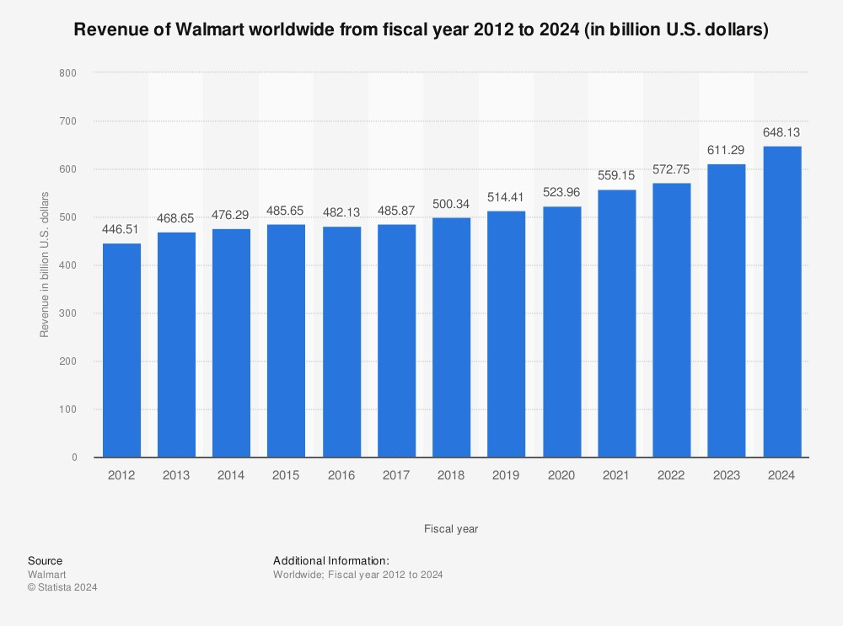
In November of 2023, Walmart had a worldwide revenue of $648 billion while being the leading fastest-moving consumer goods retailer in the world, all while spending only $3.41 billion on advertising. (Ozbun) In the same statistical overview from Statista, I was able to analyze Walmart’s projected net sales for the coming years. The graph below gives a depiction of their analysis:
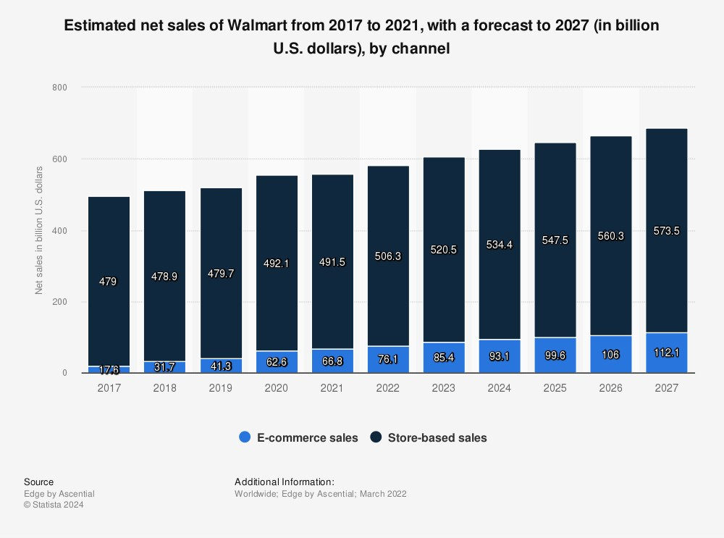
As you can see from the graph, Walmart has already seen a steady increase in their e-commerce sector while maintaining adequate store sales from 2017-2023. For 2024 – 2027, the graph depicts Walmart’s e-commerce presence to grow to over $100 billion in sales while also continuing to largely increase their store-based sales. I personally feel that these estimations are rational given their track record. Sales have steadily increased from year to year, and Walmart has already begun preparing themselves for the future of shopping with their heavy investments into e-commerce and technology, so there is no reason to doubt they will continue to see success.

Situation Analysis
Every company is bound to run into strategic issues in their business processes, even if you’re a global giant like Walmart. The most crucial strategic issue Walmart is faced with right now is the evolving e-commerce landscape and how they plan to compete in the future. Consumers today seek convenience in every shopping experience they have and largely base return service upon that convenience. The convenience consumers have grown to care about the most in recent years is online shopping. A large contributor to this shift in shopping preference can be accredited to the COVID-19 pandemic where many people had to shift to shopping online to get their everyday items. E-commerce giants like Amazon have dominated in the online shopping industry over the last decade and Walmart has recognized that they need to make changes to stay competitive long term. One such initiative Walmart has taken to try competing against other retailers such as Amazon is implementing their own premium membership program called Walmart+. The main purpose Walmart+ was instituted was to try and combat Amazon’s membership program called Amazon Prime which has become well known for its fast and free two-day shipping policy. Walmart has matched that shipping policy on many of their online goods as well; however, they still lag in terms of total e-commerce offerings in comparison to competitors.
Alternatives
There are several strategic decisions that Walmart will have to make in the coming years in order to maintain their position and continue to grow in the retail and e-commerce industries. With competitors like Amazon dominating the e-commerce industry and the retail industry always maintaining high levels of competition, Walmart must navigate their future strategic decisions in a cautious manner.
One such strategic alternative that I believe the organization would benefit from taking would be investing in stronger e-commerce infrastructure and technology. With more and more shoppers seeking the convenience that online shopping provides, it would be wise for Walmart to heavily invest in their e-commerce infrastructure to solidify their e-commerce presence for years to come. The pros of making such investments would include improved consumer experience, better website performance, and a more advanced mobile app. The cons of taking this approach would be the large financial investment required to make such changes as well as the expectancy of the e-commerce industry to continue to evolve, meaning continued investment.
Another such alternative strategic decision that Walmart can consider taking could be expanding upon their fulfillment capabilities and working harder to provide last-mile delivery services. Customer satisfaction is one of the most important factors of maintaining good returns, so by enhancing their fulfillment capabilities they can help reduce their shipping times which overall should lead to improved satisfaction levels and likely more business as well. This can be implemented by investing in expanding their current warehouses and distribution centers as well as building new ones so they can ultimately help streamline their inventory management and shipping processes. A few downsides to taking on this approach would mean yet again a large financial investment to ultimately improve and build the warehouses and distribution centers which can cause short-term strains on the company. Another con of taking this approach would be the sheer complexity of managing the last-mile delivery services and ensuring deliveries are made accurately and on time.
A third strategic approach that Walmart can take to maintain its competitive position in the retail and e-commerce industries is through taking part in strategic partnerships with other e-commerce retailers and by acquiring other e-commerce platforms. By practicing strategic partnerships with other e-commerce retailers, Walmart can accelerate their growth in the e-commerce industry by having access to new and innovative technology and expertise coming from the partnering firm. Furthermore, by acquiring other e-commerce platforms, Walmart can expand their customer base, strengthen their market position, and diversify their offerings even more. A few cons that come along with taking such an approach include the challenges that come along with integrating operations through a strategic partnership and the potential financial risks that come along with acquisitions. Integrating business operations in strategic partnerships can prove challenging as each company has its own culture and organizational structure. When integrating platforms, there can be cultural collisions between the partnering firms which can ultimately lead to unproductive partnerships. There are also risks when considering acquiring firms in e-commerce or any industry for that matter. Acquisitions are not always proven to pan out for the acquirer. Sometimes the acquiring firm overestimates the returns that can be attained by making the acquisition which can lead to financial downfall and waste of resources.
Recommendations
Of the three strategic recommendations that I suggested for Walmart, I believe they would benefit most from my first recommendation which is making significant investments in their e-commerce technology and infrastructure. Walmart has faced fierce pressure from competitors like Amazon regarding their online presence and global reach, so I feel this is a paramount area to begin bolstering an improved market position for the coming years. In comparison to the other two options, this option places more emphasis on addressing the future of shopping and addressing their fierce competition for internet market shares. While expanding their fulfillment capabilities and last-mile delivery services is still an important matter that should be addressed in the future, Walmart should address their e-commerce strategies first as it will enhance their foundation for long-term growth. The recommendation of strategically partnering with another e-commerce firm or acquiring one is still another lucrative opportunity; however, I feel Walmart would be able to save a lot more money by investing in their own e-commerce systems opposed to trying to acquire one to enhance their capabilities. By doing so, Walmart is also able to foster internal or organic growth within their own organization which makes them stronger in the long run. As for the strategic partnerships, they can offer adequate advantages of leveraging new markets; however, taking place in partnerships can sometimes cause conflict as you must mesh two or more cultures together, which can ultimately hinder growth.
Implementation
In order for Walmart to successfully implement my recommended alternative, they must start by creating a plan. This plan would begin by identifying their key objectives and metrics in making the investments and what they expect to garner in return. They must then analyze and ensure that the investments are aligned to the organization and its objectives as well as its capabilities. Once those two beginning measures have been covered is when they will be able to identify the potential obstacles they may face. The potential obstacles that I believe they face in trying to implement my recommendation would be challenges in employees resisting the changes being made. By making their e-commerce presence more dominant, some workers may grow skeptical of the new technologies as they’ve become accustomed to the processes that are already in place. This could cause some internal rift amongst the workforce and potentially lead to a decrease in workforce productivity. Another potential challenge they may face in implementing this recommendation is allocating their resources adequately. When making investments and taking on projects such as this, it is paramount that a firm ensures that they have an adequate number of resources on hand which can include time, personnel, actual money, etc. In order to function as a cohesive business unit, it is important that Walmart ensures their staff is aware and educated on the new e-commerce technology being implemented. Walmart would need to implement a skill and training development program to assist employees in learning how to use and manage the new technologies on the e-commerce platform so they can effectively perform their duties. In terms of measuring the success or failure of making this investment, Walmart should analyze their quarterly reports and look for any key performance indicators that can signal whether or not the strategy has been implemented effectively.
Contingency
When implementing such a plan as the one I recommended, it is important to be prepared for the consequences that follow the actions taken, even in the event that they are negative. This can be done by adopting a contingency plan. This plan should be sure to cover any and all potential risks and issues that could arise in the plan, so they can be well aware of issues that could impede the strategy’s implementation. Once they’ve assessed these risks and issues, they can determine the impact they would have on the company, as well as the likelihood that they actually occur. This will give Walmart an idea of whether or not the strategy is even worth the risk. Once the impact has been determined, their management team can then begin to develop response strategies to negate the harmful effects. This could involve active adjustment of resources, courses of action, and adjusting timelines as needed. A good practice in building a contingency plan is to ensure implementation of monitoring mechanisms so you can identify any trigger points to help get a warning of any potential market changes. The last key element in an effective contingency plan would be to ensure that there is adequate communication between the organization and stakeholders so that any and all issues, plans, and efforts can be openly discussed so proper action can be taken.

Bibliography:
- From humble beginnings.to redefining retail. Walmart History. (n.d.). https://corporate.walmart.com/about/history
- Walmart value chain analysis. Boardmix. (n.d.). https://boardmix.com/analysis/walmart-value-chain/
- MarketLine. (2021, February 18). Walmart Inc. Value Chain Analysis. Retrieved from Marketline Advantage Database.
- Walmart+. (n.d.). https://plus.walmart.com/?gclsrc=aw.ds&&adid=22222222220456691570&wmlspartner=wmtlabs-rv&wl0=e&wl1=g&wl2=c&wl3=671368878905&wl4=aud-1651068664026%3Akwd-330312943899&wl5=9023314&wl6=&wl7=&wl8=&veh=sem&cn=20133200314&sourceid=default&utm_adgid=146914439937&utm_term=walmart%2B&utm_devicemdl=&ui_adid=671368878905&gad_source=1&gclid=CjwKCAjwte-vBhBFEiwAQSv_xeUVDpcHMjoRzYe6Cizz3Ss-_KgoKVPYfOeAFzjE0M8B6rlKUBG5YBoCbQQQAvD_BwE
- Lanes, J. (n.d.). Walmart: Save money. live better. retail for everyone. Technology and Operations Management. https://d3.harvard.edu/platform-rctom/submission/walmart-save-money-live-better-retail-for-everyone/
- Carmely, M. (2024, March 6). Walmart target market analysis - demographics & insights. Start.io - A Mobile Marketing and Audience Platform. https://www.start.io/blog/walmart-target-market-analysis-shopper-demographics-and-insights/
- B2B ecommerce - in-depth Market Insights & Data Analysis. Statista. (n.d.). https://www.statista.com/study/44442/in-depth-report-b2b-e-commerce/
- Walmart competitors | comparably. (n.d.). https://www.comparably.com/companies/walmart/competitors
- Admin. (2023, December 26). Walmart competitor analysis - the strategy story. The Strategy Story - Simplifying Business Strategies. https://thestrategystory.com/blog/walmart-competitor-analysis/
- Rowland, C. (2023, July 23). Walmart Pestel/Pestle Analysis & Recommendations. Panmore Institute. https://panmore.com/walmart-pestel-analysis-recommendations-case-study
- Greenspan, R. (2023, July 23). Walmart Five forces analysis (Porter Model), recommendations. Panmore Institute. https://panmore.com/walmart-five-forces-analysis-porters-model-case-study
- Sans’, .tdb-post-meta{margin-bottom:16px;color:#444;font-family:’Open, Pant, R., By, Pant, R., Rajesh Panthttps://managemententhusiast.comMy name is Rajesh Pant. I am M. Tech. (Civil Engineering) and M. B. A. (Infrastructure Management). I have gained knowledge of contract management, My name is Rajesh Pant. I am M. Tech. (Civil Engineering) and M. B. A. (Infrastructure Management). I have gained knowledge of contract management, Rajesh Pant - March 8, Rajesh Pant, Rajesh Pant - February 20, 8, M., & 7, M. (2022, December 13). Walmart’s business strategy and Competitive Advantages. Management Enthusiast -. https://managemententhusiast.com/walmarts-business-strategy-and-competitive-advantages/#Competitive_Advantages_of_Walmart
- Smithson, N. (2023, July 24). Walmart SWOT Analysis & Recommendations. Panmore Institute. https://panmore.com/walmart-swot-analysis-recommendations-case-study
- Ozbun, T. (n.d.). Topic: Walmart. Statista. https://www.statista.com/topics/1451/walmart/

